Project Design Phase-II
Technology Stack (Architecture & Stack)
Date | 31 January 2026
Team ID | SWTID-2026-1597
Project Name | AI Fit Track API – Personalized Fitness Tracking with AI-Powered Insights
Maximum Marks | 4 Marks

Technical Architecture:
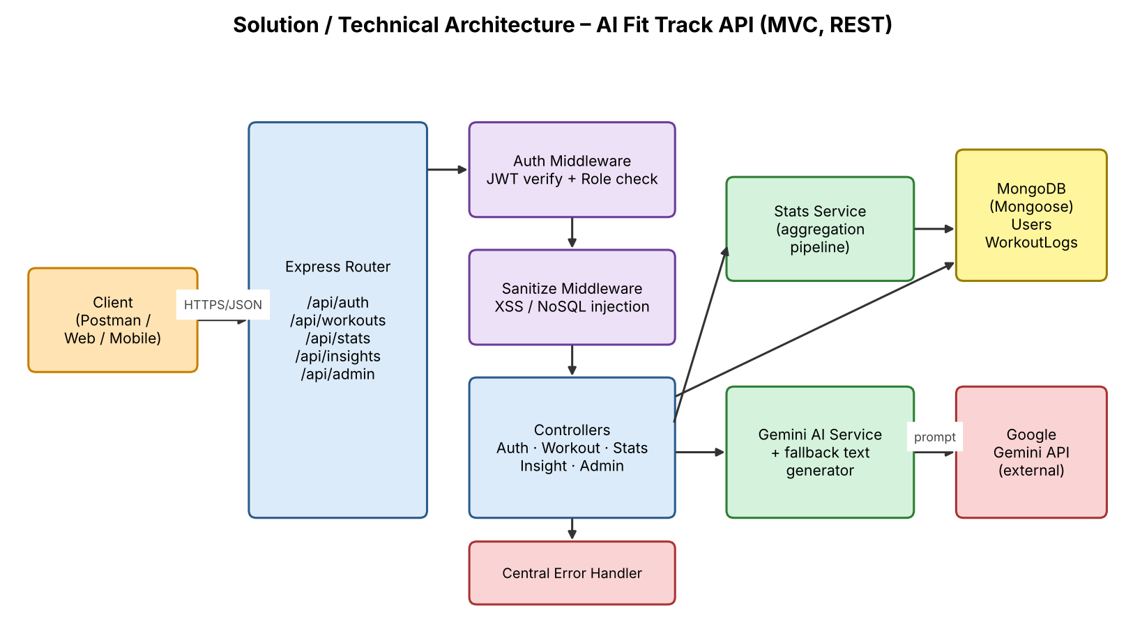
Figure 1: Technical architecture of AI Fit Track API
Table-1 : Components & Technologies:
S.No | Component | Description | Technology
1. | User Interface | Headless backend; consumed through REST clients | Postman (testing), any web/mobile client via JSON
2. | Application Logic-1 | Authentication and user management | Node.js, Express.js, JWT, bcrypt.js
3. | Application Logic-2 | Workout logging and goal tracking (CRUD) | Express controllers, Mongoose
4. | Application Logic-3 | Statistics aggregation and AI insight generation | MongoDB aggregation pipeline, Gemini AI service
5. | Database | Document collections: Users, WorkoutLogs | MongoDB (NoSQL)
6. | Cloud Database | Optional hosted database | MongoDB Atlas
7. | File Storage | Configuration and source files | Local filesystem (.env for secrets)
8. | External API-1 | Natural-language progress summaries and recommendations | Google Gemini AI (@google/generative-ai)
9. | External API-2 | Not used
10. | Machine Learning Model | Large language model for fitness insights | Google Gemini (hosted LLM)
11. | Infrastructure (Server / Cloud) | Local Server: Node.js v16+ on Windows/macOS/Linux, port 5000  Cloud: deployable to any Node host (e.g. Render, Railway) | Local, Nodemon (development)

Table-2: Application Characteristics:
S.No | Characteristics | Description | Technology
1. | Open-Source Frameworks | Server, routing, ODM and dev tooling | Express.js, Mongoose, Nodemon
2. | Security Implementations | Token auth, password hashing, role matrix, input sanitisation, central error handler | JWT, bcrypt, XSS/NoSQL-injection sanitisation, OWASP practices
3. | Scalable Architecture | Modular MVC layers with a separate service layer; stateless REST API | Node.js, Express.js (MVC)
4. | Availability | Stateless instances can be replicated; fallback mode when AI keys fail | Node.js, MongoDB Atlas replica set
5. | Performance | Aggregation done in the database; lightweight JSON responses | MongoDB aggregation pipeline

